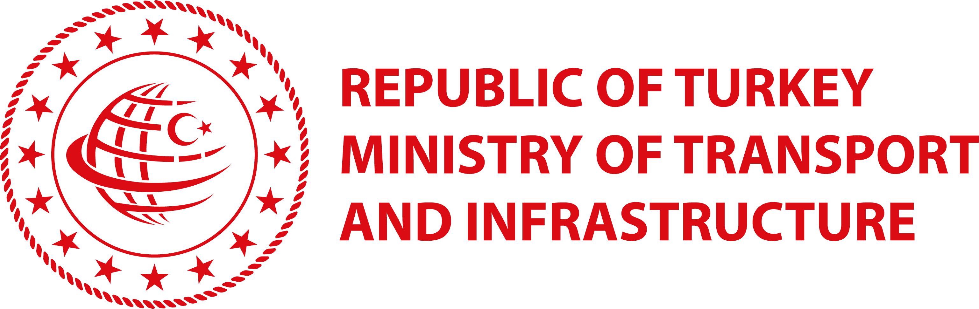
Implementation and Fulfillment of International Maritime Agreements

TRANIEE LIST FOR THE ONLINE ACVITIVIES OF THE COMCEC PROJECT
Country | Participant’s Name | Title | Department | E-mail  Address | Phone
TURKEY | Safiye TECEN | Maritime Expert | Department of Maritime Policies and International Relations/  Ministry of Transport and Infrastructure | safiye.tecen@uab.gov.tr | +903122031000
 | Çağdaş GÜRBÜZ | Marine Surveyor Engineer | Department of Ship Inspection and Inland Water Transport/  Ministry of Transport and Infrastructure | cagdas.gurbuz@uab.gov.tr | +903122031000
 | Mustafa ERGÜVEN | Maritime Expert | Department of Ship Inspection and Inland Water Transport/  Ministry of Transport and Infrastructure | mustafa.erguven@uab.gov.tr | +903122031000
 | Alper KARAEYVAZ | Marine Surveyor Engineer | Department of Safety of Navigation/  Ministry of Transport and Infrastructure | alper.karaeyvaz@uab.gov.tr | +903122031000
 | Mustafa Burak NALBANT | Lawyer | Department of Safety of Navigation/  Ministry of Transport and Infrastructure | mburak.nalbant@uab.gov.tr | +903122031000
TUNISIA | Youssef BEN ROMDHANE | General Director | Ministry of Transport and Logistic | youssef.benromdhane@transport.state.tn | +216 95 178 668
 | Hatem FEKI | Seaports executive | Ministry of Transport and Logistic | hatem.feki@transport.state.tn | +216 99 860066
 | Mohamed Sameh SOUISSI | Officer | OMMP | semah.souissi@gmail.com | +216 99 827 902
 | Bilel AYARI | Officer | OMMP | bilelayari000@yahoo.fr | +216 92 116 870
 | Rami MEZNI | Officer | OMMP | meznirami907@yahoo.fr | +216 20 642 407
LEBANON | Maya TAYYARA | Madam | Head of Maritime Training Dept. | mayatayara.mt@gmail.com | +961 1 372791
 | Haytham CHAABAN | Capt. | Marine Surveyor, PSC Officer, IMSAS Auditor | capt.chaaban@gmail.com | +961 3 894098
 | Ali HAIDAR | Capt. | Marine Surveyor, PSC Officer, IMSAS Auditor | captainhaidar@gmail.com | +961 3 742091
 | Mohamed MUSTAPHA | Eng. | Marine Surveyor, PSC Officer | engmmustapha@gmail.com | +961 3 225668
 | Hazme SAAD | Capt. | Marine Surveyor, PSC Officer | hrss67@yahoo.com | +961 3 919371

Contact Details:
COMCEC Coordination Office
Necatibey Cad. No:110/A
06580 Ankara-TURKEY
Phone : (90) (312) 294 57 10 – 294 57 30
Facsimile : (90)(312) 294 57 77 - (90)(312) 294 57 79
e-mail : comcec@comcec.org

